# **Best Practise for SEO to optimizing Website**

### **Domain names**

You should use ****sub-directory root domains**** (searchenginewatch.com/category/seo) instead of sub-domains (searchenginewatch.category.seo.com) as this is better for your overall site architecture.

You should also stay away from hyphens (search-engine-watch.com) and alternative Top-level domain names (.biz .name .info) as these are considered spammy.

### **Choose a static URL address instead of a dynamic one.**

A static URL looks like that: **your-domain-name.com/category/the-best-seo-practices**

A dynamic one can look like this:**your-domain-name.com/category/?p=028705**

### An Ideally Optimized Web Page

An ideal web page should do all of the following:

* Be hyper-relevant to a specific topic (usually a product or single object)
  + Include subject in title tag
  + Include subject in URL
  + Include subject in image alt text
  + Specify subject several times throughout text content
* Provide unique content about a given subject
* Link back to its category page
* Link back to its subcategory page (If applicable)
* Link back to its homepage (normally accomplished with an image link showing the website logo on the top left of a page)

### **Headlines and permalinks**

The headlines for your articles should be ****under 55 characters**** to ensure their complete visibility in SERPs. Make sure they’re snappy, attractive and as descriptive as possible (this is often an impossible balance). Just stay away from clickbait headlines, do not promise something that the content doesn’t deliver.

### **Meta descriptions and title tags**

Write succinctly (under 156 characters is good), clearly and make sure it’s relevant to your headline and the content of the article itself.

****Title tags**** are used to tell search engines and visitors what your site is about in the most concise and accurate way possible. The keywords in your title tag show up highlighted in search engine results (if the query uses those keywords), as well as in your browser tab and when sharing your site externally.

IMG_256

**Meta Describation**

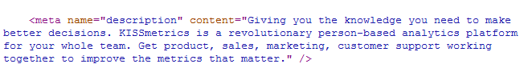

You can write your own title tag inside the <head> area of your site’s HTML:

****<head>****  
****<title>Example Title</title>****  
****</head>****

### **Place your keywords in headlines, subheadings and anchor texts.**

In a content’s structure the best places to put your keywords are **headlines, subheadings, bolded sections** within a text and **anchor texts** (copy that describes links).

### **Schema markup**

adding Schema markup to the HTML of your pages. This can help turn your search results into a rich media playground, adding star-ratings, customer ratings, images, and various other bits

<div itemscope itemtype="https://schema.org/Book"> <span itemprop="name"> Inbound Marketing and SEO: Insights from the Moz Blog</span> <span itemprop="author">Rand Fishkin</span></div>

To create schema

<https://www.google.com/webmasters/markup-helper/>

### **Tagged images (**alt attribute) Image Optimisation****

When we will upload images in the content,we should definitely do (Alt Attribute) because Google cannot ‘see’ your images, but can ‘read’ the alt text.

Image optimization is technically straightforward:

* Image name — provide a name that clearly describes what the image is.
* Alt text — use descriptive alt text to help those who can’t see the images to reinforce the image content.
* Add OpenGraph and Twitter Cards so the image is used in social shares.
* Use the image at the right physical size to ensure fast downloads.
* Optimize the image’s file size to improve loading times.
* Consider adding images to your XML sitemap.

### **Setup Google Analytics (GA) to track website traffic:**

It can track sales, what content interests your audience the most, and how your audience finds you.

### **Upload a XML Sitemap:**

### **Fix broken links:**

### **Put your robots.txt file:**

The robots.txt file, also known as the “robots exclusion protocol,” is another communication tool for search engine crawlers. Here, certain URLs can be disallowed, preventing search engines from crawling and indexing them.

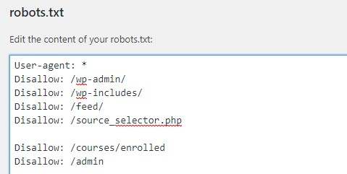

### Validate Google Search Console, Analytics, & Tag Manager

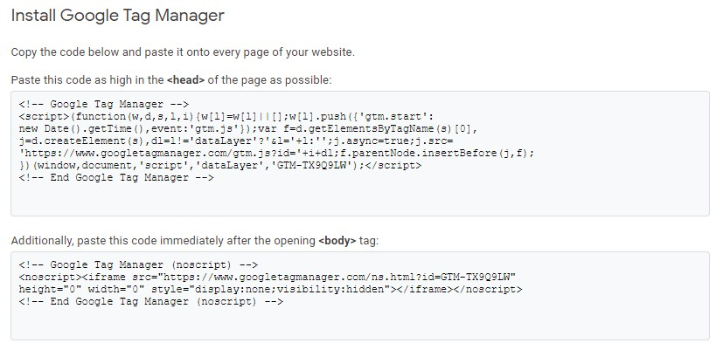

### Canonicalize All Pages

it’s finding multiple versions of the same page.

 For example, one project had the following URLs generated for its ‘About Us’ page:

* https://site.com/about-us/
* https://www.site.com/about-us/
* https://www.site.com/about-us
* https://site.com/about-us
* http://www.site.com/about-us

### Implement Proper Structured Data Markup

Implementing Structured Data markup has become the new gold standard for technical SEO practices. 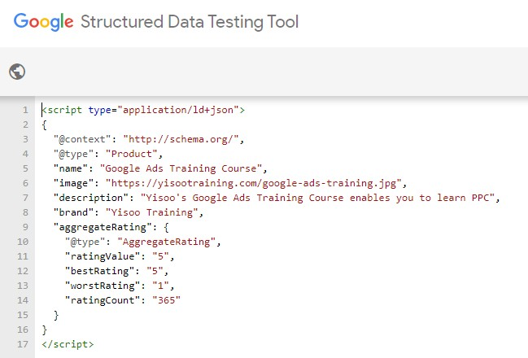

From a company’s address and location information to reviews and aggregate ratings, with Structured Data, y

## Implement Appropriate Hreflang Tags

Here are the top things we look for when reviewing hreflang tags:

* A consistent implementation method: This can be done either in the header of each page, or done in the XML sitemap. The important piece here is choosing one method and sticking to it.
* Each page should include tags for ALL of the regionalized versions that exist for that page.
* A default should be declared to be a fallback.
* Hreflang tags should not be used as replacements for canonicalization.

## Evaluate Site Performance Metrics

One of the most powerful tools for technical improvement of your website for SEO is [GTmetrix](https://gtmetrix.com/" \t "https://www.captivateseo.com/internet-marketing-blog/_blank). Essentially, this tool provides key insights about site speed performance. In turn, you can extract insights like how to minify HTML, CSS, and JavaScript, as well as how to optimize caching, images, and redirects.

These are [Google PageSpeed Insights](https://developers.google.com/speed/pagespeed/insights/" \t "https://www.captivateseo.com/internet-marketing-blog/_blank) and [Web.Dev](https://web.dev/" \t "https://www.captivateseo.com/internet-marketing-blog/_blank), both of which provide actionable guidance and in-depth analysis across a number of a variables.

## **Identify Crawl Errors, Broken Links, & Duplicate Meta Data**

With the help of tools like Google Search Console, [Raven Tools](https://raventools.com/" \t "https://www.captivateseo.com/internet-marketing-blog/_blank), [Screaming Frog](https://www.screamingfrog.co.uk/seo-spider/" \t "https://www.captivateseo.com/internet-marketing-blog/_blank), [Moz](https://moz.com/link-explorer" \t "https://www.captivateseo.com/internet-marketing-blog/_blank), or our personal favorite, [SEMrush](https://www.semrush.com/" \t "https://www.captivateseo.com/internet-marketing-blog/_blank), you can efficiently identify technical SEO issues that may be hindering a site’s performance.

## **[Local SEO](https://www.searchenginewatch.com/category/local/)**

### **Get Your NAP Accurate & Consistent:**

For your local SEO to be effective, you need to make sure you have a consistent NAP – name, address and phone number.

### **Claim your spot on Google My Business:**

### **Build citations:**

### **Encourage your customers to leave reviews:**

### **Target the community with content to earn local links:**

# The content marketing funnel

# What are search engines NOT looking for?

**Awareness — top of the funnel**

Awareness content will typically be your blog and informational articles.

We are helping your prospective customer understand the problems they face and illustrating your experience and credibility in solving them.

* Blog posts
* Informational articles
* Webinars
* Comprehensive guides
* FAQs

**Consideration — middle of the funnel**

The content at the consideration stage helps your prospect compare you against the other offerings out there. This tends to be practical content that helps the customer make a decision.

* Case studies
* Product or service information
* Product demonstration videos
* User guides

**Conversion — bottom of the funnel**

Bottom-of-the-funnel content drives conversions and should gently encourage a sale or lead.

* Reviews
* Testimonials
* Free trial
* Free consultation

### **Keyword stuffing**

Overusing keywords on your pages, especially when they obviously affect the readability of your site. It’s debatable whether Google even still uses keywords as a ranking factor anymore.

### **Link buying or excessive link exchanging**

Thinking of approaching a link farm? Just don’t do it. It’s not even worth it. The most valuable links to your site are the ones that come from authority sites within your own niche.

### **Annoying ads**

Anything overly intrusive that destroys the pleasure of reading your content and slows down your site speed.

### **Mobile app interstitials**

If you present mobile visitors with a full-screen advert to download your app, Google will consider you [no longer mobile friendly](https://www.searchenginewatch.com/sew/news/2424256/google-gets-tough-on-mobile-app-interstitials).

### **Duplicated content**

You should be aware of scraper sites, stealing your content automatically and republishing as your own.

### **Hidden text and links**

There are a ways to manipulate rankings that a user may not ever see, but Google will probably find and punish you for.